**Wire-Frame Design**

**STORES SALES PREDICTION**

|  |  |
| --- | --- |
| Written By | Enamul Islam Mondol |
| Document Version | 1.0 |
| Last Revised Date | 8-1-2023 |

**Document Change Control Record:**

|  |  |  |  |
| --- | --- | --- | --- |
| **Version** | **Date** | **Author** | **Comments** |
|  |  |  |  |
|  |  |  |  |
|  |  |  |  |
|  |  |  |  |
|  |  |  |  |
|  |  |  |  |
|  |  |  |  |
|  |  |  |  |
|  |  |  |  |
|  |  |  |  |
|  |  |  |  |
|  |  |  |  |
|  |  |  |  |
|  |  |  |  |
|  |  |  |  |
|  |  |  |  |

**Reviews**

|  |  |  |  |
| --- | --- | --- | --- |
| **Version** | **Date** | **Reviewer** | **Comments** |
|  |  |  |  |

### **Approval Status:**

|  |  |  |  |  |
| --- | --- | --- | --- | --- |
| **Version** | **Review date** | **Reviewed By** | **Approved By** | **Comments** |
|  |  |  |  |  |

**API Home Page:** On the API homepage the user will be able to see the details of API i.e., parameters that have to pass as json data also URL of API call.

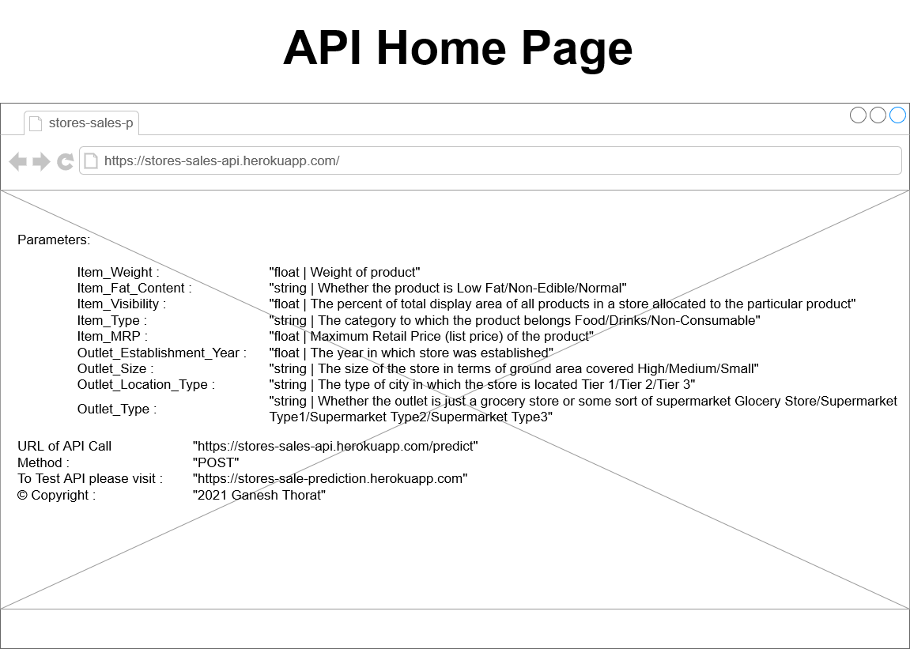

**Webapp Home page:** On the homepage the user will be able to see the heading of the project name. And there will be inputs which user needs to give.

